**Task 1: Create a Function app**

In this task, we will create a Function app.

1. Sign in to the [Azure portal (https://portal.azure.com)](https://portal.azure.com/).
2. From the **All services** blade, search for and select **Function App** and then click **+ Add**.
3. On the **Basic** tab of the **Function App** blade, fill in the Azure Function App settings fields (replace **xxxx** in the name of the function with letters and digits such that the name is globally unique). Leave the defaults for everything else.

| **TABLE 1** | |
| --- | --- |
| **Settings** | **Value** |
| Subscription | Ensure the **Concierge Subscription** |
| Resource group | Choose **[sandbox resource group name]** (Create new) |
| Function App name | **function-xxxx** |
| Publish | **Code** |
| Runtime stack | **.NET Core** |
| Region | **East US** |
|  |  |

1. Click **Review + Create** and, after verification, click **Create** to begin provisioning and deploying your new Azure Function App.
2. Wait for the Notification that the resource has been created.
3. Open All Services and open the Function App page. Then click the **Refresh** to verify your new resource is *running*.

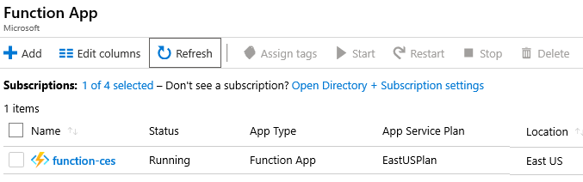

**Task 2: Create an HTTP triggered function and test**

In this task, we will use the Webhook + API function to display a message when there is an HTTP request.

1. Click on the newly created Function App in Azure portal.
2. Click Functions. Then "**+**" button next to Add near the top of the page. Notice all the choices for functions you could build. Then click **HTTP trigger**.

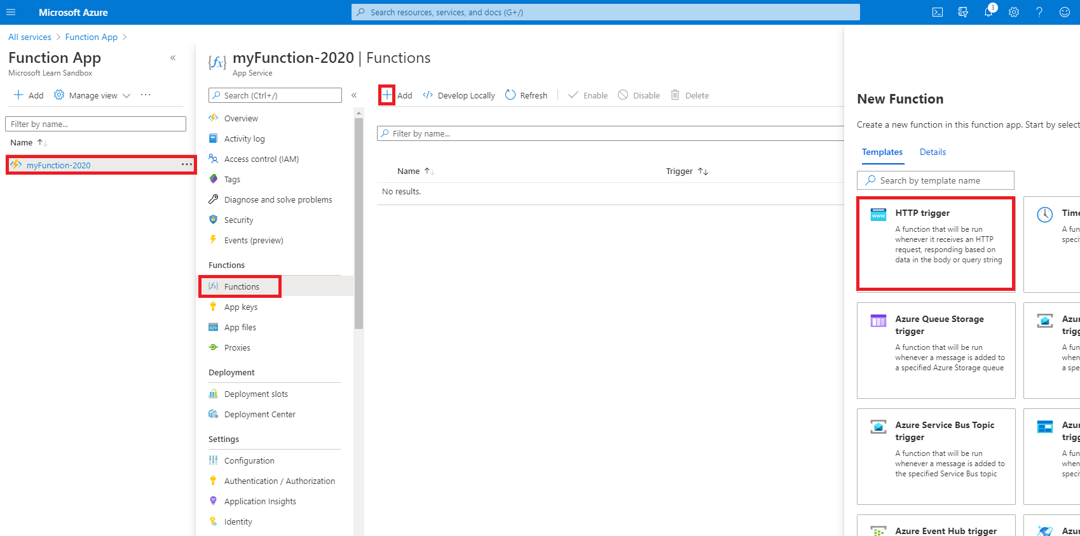

1. Review the default values of Function name = **HttpTrigger1** and Authorization Level = **Function**. Then click **Create Function**. This will run a function whenever the app receives an HTTP request. Review other templates that you can choose from.

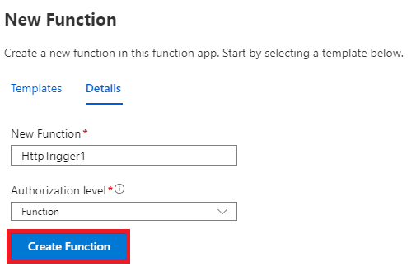

1. Your new **HttpTrigger1** function has been created, the overview page is opened.

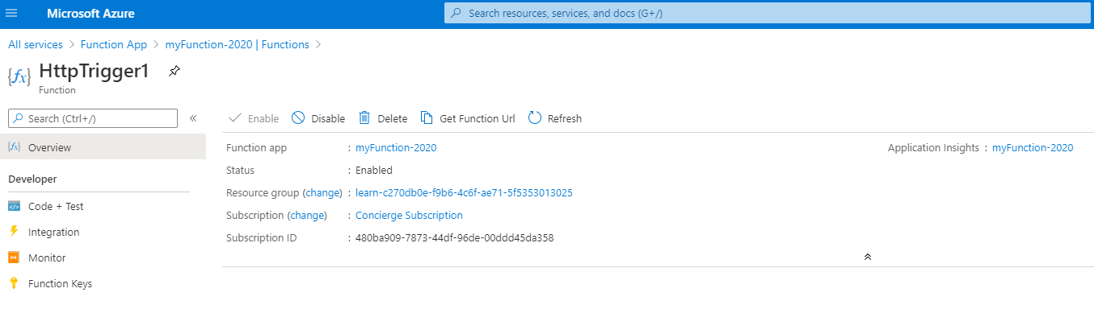

1. Click on the **Code + Test** entry in the menu. Notice the code is designed to run an HTTP request and log information. Also, notice the function returns a Hello message with a name.

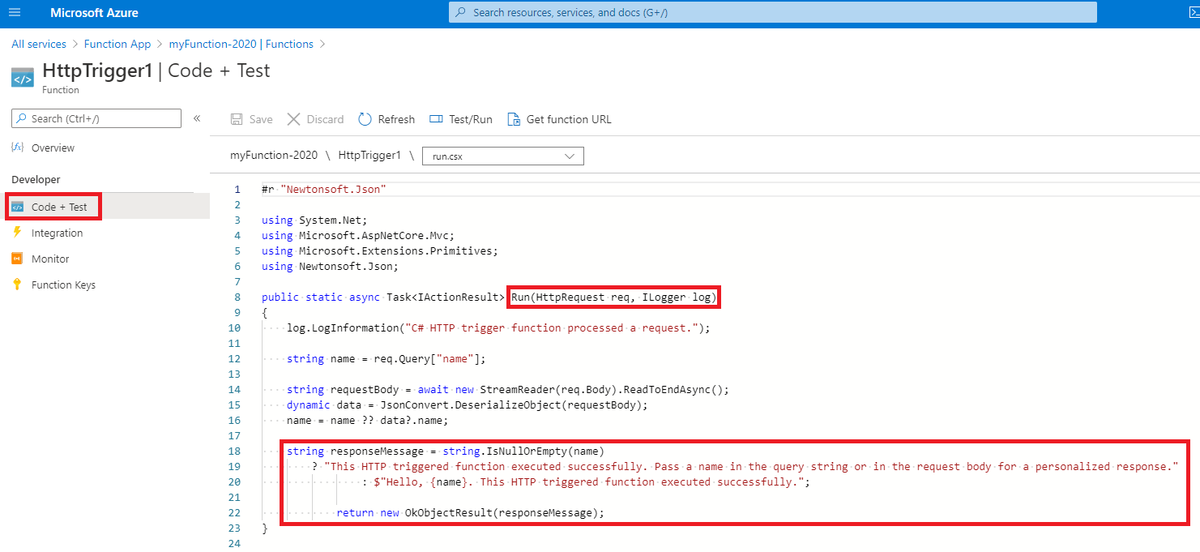

1. Click **Get function URL** from the top section of function editor.
2. Ensure that the value in the **Key** drop-down list is set to **default**. Then, click **Copy to clipboard** to copy the function URL.

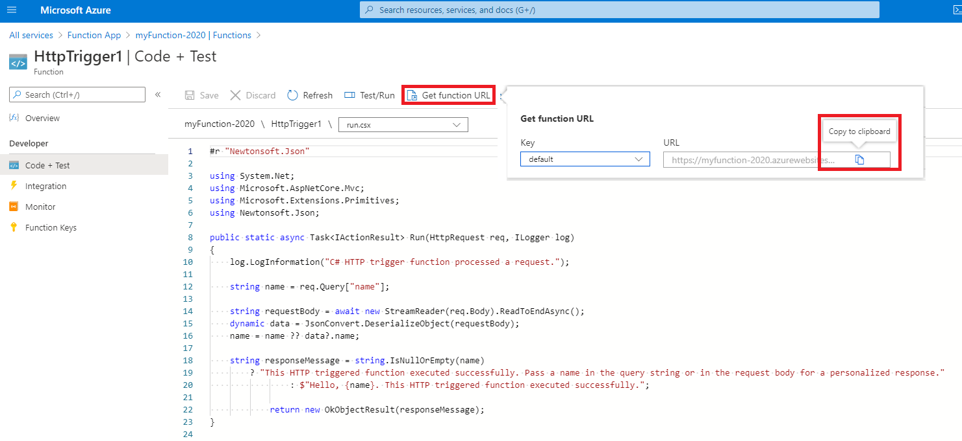

1. Open a new browser tab and paste the copied function URL into your web browser's address bar. When the page is requested the function will run. Notice the returned message stating that the function requires a name in the request body.

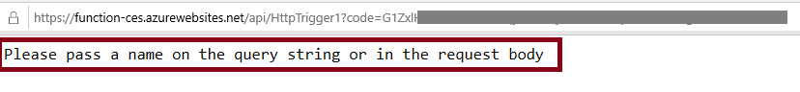

1. Append **&name=yourname** to the end of the URL.

**Note**

Replace **yourname** with your first name. For example, if your name is Cindy, the final URL will resemble the following https://azfuncxxx.azurewebsites.net/api/HttpTrigger1?code=X9xx9999xXXXXX9x9xxxXX==&name=cindy



1. When your function runs, trace information is written to log files in Azure. To view the logs in Azure portal, return to the function editor and, at the bottom of the page, click **Logs**.

